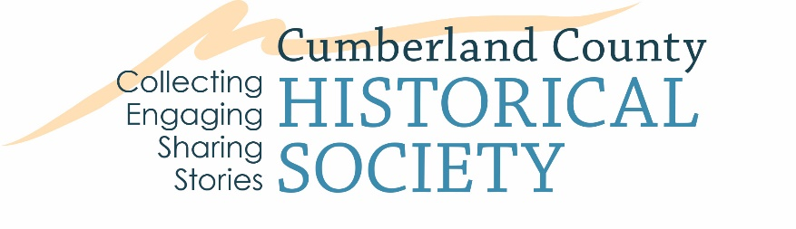

Oral History Release Form
Project name: The Elizabeth V. and George F. Gardner Digital Library
Date:
Interviewer:
Recording number:
Name of person(s) interviewed:
Address:(optional)

Telephone number: (optional)
Date of Birth: (optional)
By signing the form below, you give your permission for any of the recordings/video made during this project to be used by the Cumberland County Historical Society (CCHS). In signing, you understand that your interview and any transcript made of it will be made available to the public by CCHS for research, educational, and project publicity purposes. It may be cited, quoted from, published in original or edited form, or broadcast in any medium that CCHS deems appropriate.

Interviewee Name (print):
Interviewee Signature:
Date:
Comments:
Would you like a Courtesy Copy of Interview via email: ☐
Interviewer Name (print):
Interviewer Signature:
Date:

